|  |  |  |  |  |  |  |  |  |
| --- | --- | --- | --- | --- | --- | --- | --- | --- |
| STUDENT NAME: Hui Yin Ting | | | | | PROGRAMME: BSc IS & Comp Suite | | | |
| STUDENT NUMBER: St20104639 | | | | | YEAR: 17/18 | | GROUP: B | |
| Module Number: CIS4005 | Term: YR | | | | Module Title: Developing Quality Software and Systems I | | | |
| Tutor Responsible For Marking This Assignment: : Catherine Tryfona | | | | | | | | |
| Module Leader: Catherine Tryfona | | | | | | | | |
| Final report Due Date: Multiple submission (see submission details) | | |  | | | | | |
| ASSIGNMENT TITLE: PRAC1 Team Software Development Project | | | | | | | | |
| FEEDBACK DATE(Return of assignments to students): Within 20 working days of submission | | | | | | | | |
| **SECTION A: SELF ASSESSMENT (TO BE COMPLETED BY THE STUDENT)** | | | | | | | | |
| In relation to each of the set assessment criteria, please identify the areas in which you feel you have strengths and those in which you need to improve. Provide evidence to support your self-assessment with reference to the content of your assignment. | | | | | | | | |
| STRENGTHS:  Design and critical evaluation. | | | | AREAS FOR IMPROVEMENT:  Fluidity of report. | | | | |
| I certify that this assignment is a result of my own work and that all sources have been acknowledged:  Signed: Hui Yin Ting Date 07/05/2018 | | | | | | | | |
| SECTION B: TUTOR FEEDBACK | | | | | | | | |
| STRENGTHS | | | | AREAS FOR IMPROVEMENT AND TARGETS FOR FUTURE ASSIGNMENTS | | | | |
| MARK/GRADE AWARDED | | DATE: | | | | SIGNED | | |
| ASSIGNMENT MODERATED BY: | | | | | | | | DATE |
| MODERATOR’S COMMENTS: | | | | | | | | |

****

**CARDIFF METROPOLITAN SCHOOL OF MANAGEMENT:**

**DEVELOPING QUALITY SOFTWARE & SYSTEMS GROUP REPORT**

**MODULE: CIS5005 Developing Quality Software & Systems**

**Student Name:** Tom Jones, Chris Marsden, David Hui and Luke Tomkins

**Student Number:** st20102890, st20105977, st20104639 and st20110045

**Word Count:** 2539/2500 (Excluding References and Appendix).

**Contents**

[1.0 Introduction 4](#_Toc513489893)

[2.0 Project Scope 5](#_Toc513489894)

[3.0 Requirements Gathering 8](#_Toc513489895)

[3.1 Feedback 9](#_Toc513489896)

[4.0 Design 10](#_Toc513489897)

[5.0 Testing 12](#_Toc513489898)

[6.0 Critical evaluation of the software 16](#_Toc513489899)

[7.0 Bibliography 18](#_Toc513489900)

# 1.0 Introduction

More than three million people are diagnosed with diabetes in the UK as of 2017. Gluco-Graph was developed by a group of four university students and is an app that assists diabetics by allowing the user to store blood sugar levels and display them in a graph. Gluco-Graph also has a feature that allows users to search a database of food for nutritional information.

|  |  |
| --- | --- |
| Luke Tomkins | st20110045 |
| Tom Jones | st20102890 |
| David Hui | St20104639 |
| Chris Marsden | st20105977­­ |
| CV and LinkedIn pages are in individual reports. | |

# 2.0 Project Scope

In 2016 3.7 Million people were diagnosed with Diabetes in the UK alone (DiabetesUK, 2018). Tracking blood glucose levels can provide useful information for diabetes management. For example, helping to understand the effects of diet, exercise and other factors that can affect blood sugar levels, how well you’re reaching overall treatment goals as well as being able to monitor for signs of hyper/ hypo glycemia if a person’s blood sugar levels are too high or two low. (Diabetes UK, n.d.)

Whilst paper-based record keeping has been around for years, modern technology allows for people to track, store and lookup information at the touch of a button with a smart phone. For this reason, Gluco-Graph offers a solution to this by allowing users to store blood glucose readings on a local device and display the readings as a graph. The use of a graph offers a visual representation of the stored data which is favoured to reading textual data (Brigham, 2016). Gluco-Graph was developed on mobile as this also eliminates the easy to forget factor as a person nowadays always carries their smartphone on their person.

There are existing apps on the market to help diabetics manage their condition a study found that a group of type 2 diabetics using a mobile health apps experienced lower blood sugar levels than those who didn’t (Pharmacy Times, 2013).

MyNetDiary (Play.google.com, n.d.) is a mobile app for both Android and IOS which allows users to track blood sugar levels and access to a dietary plan to manage sugar intake. Another app we looked at was Fooducate (Play.google.com, n.d.). This app, unlike MyNetDiary provides nutritional information about foods. Gluco-Graph combines features of both these apps while also offering a simplified, seamless user interface.

The aim of GlucoGraph is to provide people with Type1 and Type2 diabetes a utility application that would allow users to log their blood glucose levels and look up nutritional information for their food.

The application will be developed for Android OS as our team has had more experience developing for this platform and we have better access to Android studio the IDE we will be using for this project. The two key deliverables for this project will be the Glucose log where users enter their blood glucose levels into a database and then have them displayed back on a graph showing the level as well as a small description and time of the log.

The second key deliverable will be the search function that will enable users to look up nutritional facts about their food. From interviewees we found that these are the two most desirable features, so these will be needed to implement for the project to be deemed successful.

Due to the nature of the project, a Waterfall development methodology will be deployed to complete this project. This will allow us to follow a robust structure for the group to follow with clear milestones to be met that ensures the project is on track for the deadline. Waterfall is more beneficial to the project than the likes of an evolutionary approach, as requirements are elicited early and are highly unlikely to change. It is likely some Agile will be implemented once development is commenced, this will allow for testing and feedback from stakeholders to be taken into consideration to make up for time constraints.

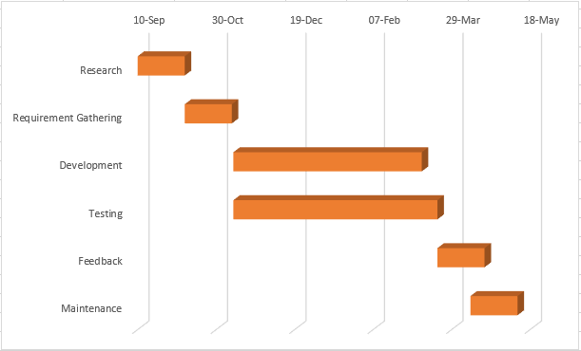

Figure 1

Figure 1 represents the Gantt chart followed throughout the project. An initial 30 days was allocated to research, here existing apps and diabetes was looked into. The next 30 days were then assigned to eliciting the user requirements through interviews. Interviews were not conducted first as it allowed ideas to be developed and suggested during the interviews. Once requirements were gathered, development commenced. The workload was split up and allocated across the team evenly. Due to the nature of the project development and testing were ran in an agile way, different to the waterfall nature used prior to this. After testing was completed, feedback interviews and maintenance were planned but due to time constraints any further work had to be put on hold.

Version control is needed so that different areas of the project can be worked on simultaneously at the same time. Bitbucket was chosen as the version control software. Bitbucket is a web-based version control service owned by Atlassian, it works by hosting repositories. BitBucket was a suitable version control for the group, as it is free for 5 users to be in a repository and users can create an unlimited number of private repositories.

Bitbucket is an easy to use version control method, supported by a git GUI called SourceTree. SourceTree provides easier use of bitbucket without the hassle and expert knowledge to use the command line interface. SourceTree can be operated simply by cloning the current project through BitBucket to your local machine, edit the project and then pushing the changes back to the repository and committed to its branch with a comment and the author of the commit.

Due to the nature of the roles within the team, work was allocated for different functionalities. BitBucket allowed us to create different branches in the repository for development and later merge these together. This can prevent problems such as different group members working over each other and may cause erasing of another member’s progress.

# 3.0 Requirements Gathering

During requirement gathering, the group interviewed potential stakeholders, with a variety of both type 1 and 2 diabetes. The interviews were structured with six questions asking about how often they take their insulin and whether they would be interested in setting reminders, among other questions regarding features for the application. Using the results from this stage of interviews will enable us to draw out key features that would need to be included.

It’s easy to paint the broad strokes with an app, but it’s difficult to gage what the everyday user would want specifically from a diabetic app. Ultimately the user will decide whether they like the app, therefore it’s vital to understand what the user would want, and interviews are an effective way to gather information. 5 stakeholders were interviewed about potential features and whether they would benefit from such a feature. From the interviews, we were able to prioritise the proposed features, with the glucose graph and nutritional database being must have features. The use of a graph allows users to visualise their blood glucose data instead of a generic textual delivery. Not every interview proved significantly helpful, however it gave the team more insight into what a diabetic user would need, as well as validating our own ideas. Ultimately the elicitation sessions gave the group a real insight into app requirements.

The interview questions were as follows:

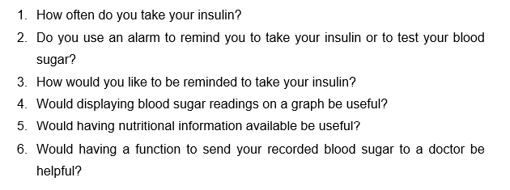

# 3.1 Feedback

It was intended that a second session with stakeholders would be arranged and feedback would be given on UI and functionality. However, due to time constraints the group was not available to complete this. Gathering more feedback from potential users would have given us a clearer idea as to whether our app was on track for meeting user requirements. From the initial interviews, the feedback given showed positive results. The app excited most if not all our interviewees and the key function of the app (the graph) interested our interviewees. Therefore, it would have been even more insightful to gage the general perception of our prototype.

# 4.0 Design

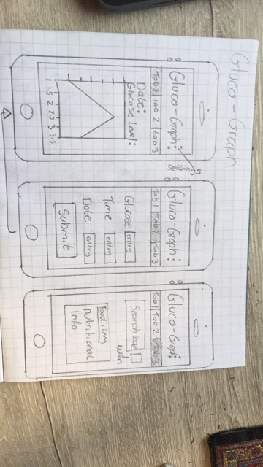Prior to development, Wiredrawing’s were drawn out with design ideas being pitched within the team. Wiredrawing’s were preferred as they allowed the team to quickly portray their ideas without and commitments. These low-fi wiredrawing’s were then used within the requirement elicitation interviews and presented to the stakeholders.

Figure

During the design phase, Schneiderman’s UI design principles, (Schneiderman, 2018) were considered throughout. The interface was designed with clarity in mind. This ensured it was obvious to the user that a button was a button and that the interface was seamlessly navigated. Figure 3 below shows the use of an active tab indicator colour and obviously labelled tabs. The use of these provides the user with confidence while navigating the app as constant reassurance of their location using the app is provided. A universally recognized settings button is used and consistently located in the top right of the screen throughout the app. (Hoober, 2013), Also states that 49% of users rely on one thumb to get things done on their phone, this creates a green zone where common actions should be placed on the UI which make for comfortable one-thumb interaction. Subsequently, the navigation menu was placed in this green zone to allow for ease of navigation.

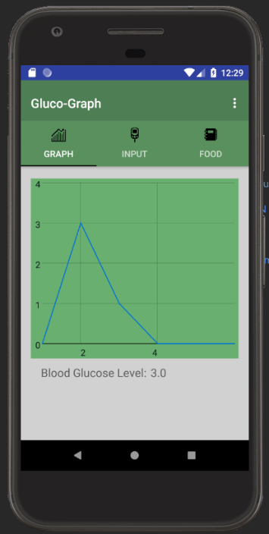

Figure 3

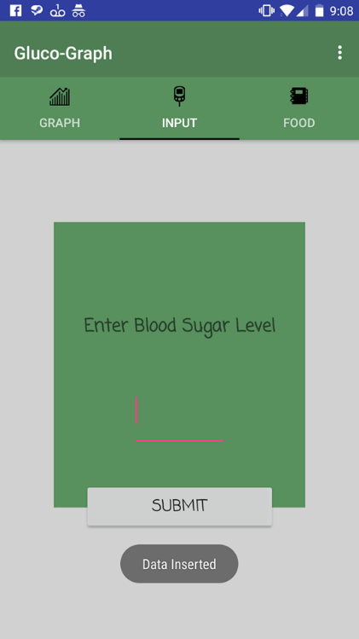It is also important to note that each screen within the app is limited to one primary action per screen. As suggested by (Schneiderman, 2018), a screen that supports two or more primary actions can become confusing, it is best practice to limit one primary action per screen, this ensures it is easy to learn, use and maintain the app. Another important principle that was considered for design was offering user informative feedback for an interaction. Figure 3 shows that when a user adds a record to the blood glucose graph, the user receives a confirmation message that the record has been added, seen as ‘Data Inserted’. This inspires confidence in the user.

Figure 4

# 5.0 Testing

Once development was completed we conducted a series of tests on the app to ensure that it ran as it was supposed to on mobile. Due to time constraints we couldn’t allocate time for another round of development to implement fixes, for the issues bought up in the first round of testing. Below are results from testing.

|  |  |
| --- | --- |
| Test 1 - Load Time | |
|  | |
| Test Device | OnePlus 5 (Android 7.1.1, Oxygen OS 4.5.2, API 25) |
| Expected result | App loads onto first tab showing the graph screen |
| Load Time | 0.34s |
| Outcome | App loaded almost instantly |
| Action needed | Test was conducted on a fresh version of the application because of this the database displays a message box when the Blood Glucose database is empty. |

|  |  |
| --- | --- |
| Test 2 - Tab 1: graph screen | |
| C:\Users\Luke\AppData\Local\Temp\7zEC73C20CB\Screenshot_20180507-092052.pngC:\Users\Luke\Downloads\Screenshot_20180507-092059.png | |
| Test Device | OnePlus 5 (Android 7.1.1, Oxygen OS 4.5.2, API 25) |
| Expected result | blood glucose levels get displayed as a line graph when the user clicks on one of the points the value of the point gets displayed at the bottom of the screen |
| Outcome | Results display on the graph as intend while results returned at the bottom of the screen were coming out as a repeating decimal. |
| Action needed | Find a way to return the blood glucose level 2 places after the decimal |

|  |  |
| --- | --- |
| Test 3 - Tab2: input screen | |
|  | |
| Test Device | OnePlus 5 (Android 7.1.1, Oxygen OS 4.5.2, API 25) |
| Expected result | User enters a decimal figure for blood glucose level and text field clears when user presses submit |
| Outcome | Works as intended |
| Action needed | N/A |

|  |  |
| --- | --- |
| Test 4 - Tab 3: Search Screen | |
|  | |
| Test Device | OnePlus 5 (Android 7.1.1, Oxygen OS 4.5.2, API 25) |
| Expected result | User can scroll through entries or search for entries. When user clicks on one of the entries the view expands showing nutritional information for the selected item |
| Outcome | Search function loads okay but for some reason when the user selects an entry it will expand open as intended but will also open every entry 15 place’s from the selected entry  Each entry only returns the results of the last query placing the last column of the database the glucose column, and places it in the space for each of the other fields e.g. Fat, Energy, Total sugar |
| Action needed | We couldn’t find the source of the 15 spaces bug how ever we do know the source of the placement bug more time will be needed to find cause of the problem  <Namelist???> |

# 6.0 Critical evaluation of the software

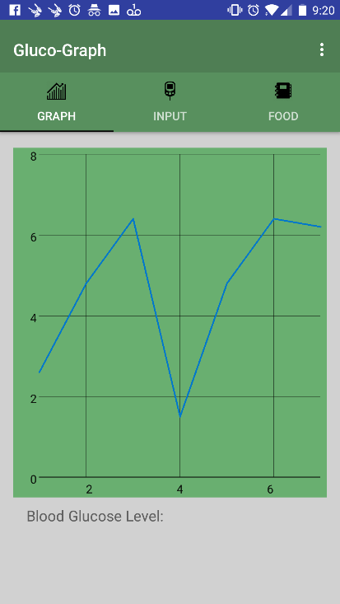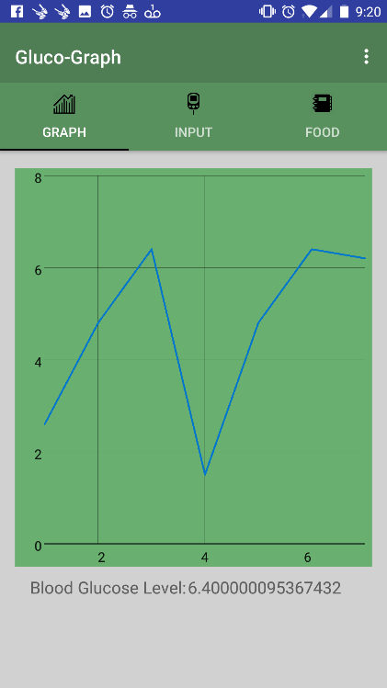

The project scope of GlucoGraph was to develop an Android application to help people with type 1 and type 2 diabetes manage their condition through the ability to digitally log their blood glucose levels and have them displayed back as a line graph, users can also select a point on the line graph and have the value displayed underneath. This feature was successfully implemented however there is a bug that makes the result return a repeating decimal.

If we managed to get the feature working, we would have also displayed when the log was made and a small description if the user wanted to add notes to the log entry.

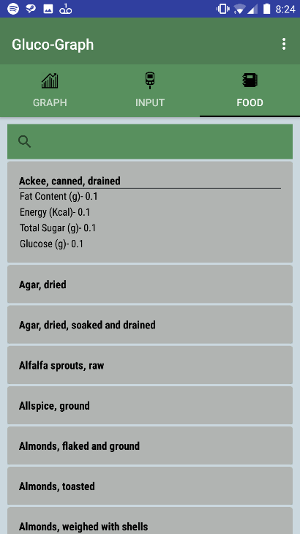

The second feature that was required by the project scope was the nutritional information search, we were able to implement the UI and backend-code for this feature, yet we did have issues returning the right information from the nutrition database. As found during testing the results only return the contents of the glucose column in the database. Although we couldn’t return the correct results the feature still works as intended user can scroll through entries or search using the text field at the top of the screen.

Development was a hybrid of the Waterfall and agile development life cycles, the project started with a highly structured planning and design phase with research and interviews being conducted at the beginning of the project this was where the initial idea was conceived and where the research and interviews were conducted gather information to understand the scope of the project.

We chose to initially work under the waterfall cycle due to its solid structure of plan, design, develop, limiting the amount of backtracking to previous stages if the phase is already completed and agreed upon by the group.(Sharma, 2016)

With the initial project planning completed we moved onto the design phase where we used feedback from the initial interviews and research to assist in designing the application as well as detailing what the user requirements were for the project to be deemed a success.

After planning and design phases were complete we changed our development process to be more in line with agile as we wanted to work iteratively, using feedback from a second round of interviewees. Agile allows for dynamic development where improvements can be made based on the users needs rather than a set-in stone waterfall project scope. (Agile Alliance, n.d.)

Overall, we feel as though GlucoGraph met the project scope of delivering a utility application with an easy to navigate user interface, as well as implementing both features that gained the most interest during the interview process. Unfortunately, due to the bug in the search function the application isn’t fully operational yet given more time we would have conducted a second round of interviews for user feedback as well another development and testing phase to find fixes for the bugs found in the initial round of testing.

# 7.0 Bibliography

DiabetesUK (2018). *Diabetes Prevalence 2017 (November 2017)*. [online] Available at: https://www.diabetes.org.uk/professionals/position-statements-reports/statistics/diabetes-prevalence-2017 [Accessed 3 May 2018].

Diabetes UK. (n.d.). *Testing*. [online] Available at: https://www.diabetes.org.uk/guide-to-diabetes/managing-your-diabetes/testing [Accessed 7 May 2018].

Brigham, T. (2016). Feast for the Eyes: An Introduction to Data Visualization. *Medical Reference Services Quarterly*, [online] 35(2), pp.215-223. Available at: https://doi-org.ezproxy.cardiffmet.ac.uk/10.1080/02763869.2016.1152146.

Pharmacy Times (2013). *Diabetes Apps: Impacting Patients' Lives*. [online] Available at: http://www.pharmacytimes.com/publications/issue/2013/march2013/diabetes-apps-impacting-patients-lives [Accessed 3 May 2018].

Play.google.com. (n.d.). *Calorie Counter - MyNetDiary*. [online] Available at: https://play.google.com/store/apps/details?id=com.fourtechnologies.mynetdiary.ad&hl=en\_GB [Accessed 7 May 2018].

Play.google.com. (n.d.). *Fooducate Healthy Weight Loss & Calorie Counter*. [online] Available at: https://play.google.com/store/apps/details?id=com.fooducate.nutritionapp&hl=en\_GB [Accessed 7 May 2018].

Sharma, L. (2016). *WaterFall Model in Software Developement Life Cycle | SDLC*. [online] Toolsqa.com. Available at: http://toolsqa.com/software-testing/waterfall-model/ [Accessed 7 May 2018].

Agile Alliance. (n.d.). *Agile Alliance*. [online] Available at: https://www.agilealliance.org [Accessed 7 May 2018].

Schneiderman, B., 1987. *Eight Golden Rules of Interface Design,* s.l.: s.n.